UNITED STATES

SECURITIES AND EXCHANGE COMMISSION

Washington, D.C. 20549

FORM 8-K

CURRENT REPORT

PURSUANT TO SECTION 13 OR 15(d)

OF THE SECURITIES EXCHANGE ACT OF 1934

Date of Report (Date of earliest event reported): August 18, 2020

WYNN RESORTS, LIMITED

(Exact name of registrant as specified in its charter)

 |  | Nevada |  | 000-50028 |  | 46-0484987
 |  | (State or other jurisdiction |  |  | (Commission |  | (I.R.S. Employer
 |  | of incorporation) |  |  | File Number) |  | Identification No.)
 |  | 3131 Las Vegas Boulevard South
 |  | Las Vegas, Nevada |  |  |  | 89109
 |  | (Address of principal executive offices) |  |  |  |  | (Zip Code)
 |  |  |  | (702) 770-7555
 |  |  |  | (Registrant’s telephone number, including area code)
 |  |  |  |  | Not Applicable
 |  |  |  | (Former name or former address, if changed since last report)
Securities registered pursuant to Section 12(b) of the Act:
 | Title of each class |  |  | Trading Symbol(s) |  |  | Name of each exchange on which registered
Common stock, par value $0.01 |  |  |  | WYNN |  |  | Nasdaq Global Select Market

Check the appropriate box below if the Form 8-K filing is intended to simultaneously satisfy the filing obligation of the registrant under any of the following provisions:

- Written communications pursuant to Rule 425 under the Securities Act (17 CFR 230.425)

- Soliciting material pursuant to Rule 14a-12 under the Exchange Act (17 CFR 240.14a-12)

- Pre-commencement communications pursuant to Rule 14d-2(b) under the Exchange Act (17 CFR 240.14d-2(b))

- Pre-commencement communications pursuant to Rule 13e-4(c) under the Exchange Act (17 CFR 240.13e-4(c))

Indicate by check mark whether the registrant is an emerging growth company as defined in Rule 405 of the Securities Act of 1933 (§230.405 of this chapter) or Rule 12b-2 of the Securities Exchange Act of 1934 (§240.12b-2 of this chapter).

Emerging growth company ☐

If an emerging growth company, indicate by check mark if the registrant has elected not to use the extended transition period or complying with any new or revised financial accounting standards provided pursuant to Section 13(a) of the Exchange Act. ☐

Item 7.01 Regulation FD Disclosure.

On August 18, 2020, Wynn Macau, Limited (“Wynn Macau”), an indirect subsidiary of Wynn Resorts, Limited (the “Wynn Resorts” or the “Company”) with its ordinary shares of common stock listed on The Stock Exchange of Hong Kong Limited (the “HKSE”), filed with the HKSE an announcement (the “Announcement”) of Wynn Macau’s proposed issuance of senior notes (the “Offering”). Wynn Resorts owns approximately 72% of Wynn Macau’s ordinary shares of common stock. The Announcement is furnished herewith as Exhibit 99.1.

In connection with the Offering, Wynn Macau intends to provide potential investors with certain financial information. A summary of this information is attached to this report as Exhibit 99.2 and is incorporated herein by reference.

The information furnished pursuant to this Item 7.01 (including Exhibits 99.1 and 99.2 hereto) shall not be deemed to be “filed” for purposes of Section 18 of the Securities Exchange Act of 1934, as amended (the “Exchange Act”), or otherwise subject to the liabilities of that section, nor shall it be deemed incorporated by reference in any filing under the Securities Act of 1933, as amended (the “Securities Act”), or the Exchange Act, except as shall be expressly set forth by specific reference in such a filing.

This Current Report on Form 8-K contains forward-looking statements within the meaning of Section 27A of the Securities Act and Section 21E of the Exchange Act. Such forward-looking statements are subject to numerous assumptions, risks and uncertainties that could cause actual results to differ materially from those described in such statements. Such forward-looking statements are based on management’s expectations or beliefs as of August 18, 2020. Factors that might cause such differences include, but are not limited to, a variety of economic, competitive, and regulatory factors, many of which are beyond the Company’s control and are described in Wynn Resorts’ Annual Report on Form 10-K filed by Wynn Resorts, Limited on February 28, 2020 with the Securities and Exchange Commission (the “SEC”) and the other reports Wynn Resorts files from time to time with the SEC. Wynn Resorts undertakes no obligation to revise or publicly release any updates to such statements based on future information or actual results.

 | Item 9.01 |  | Financial Statements and Exhibits.
 | (d) Exhibits.
 | Exhibit No. |  | Description
99.1 |  |  | Announcement of Wynn Macau, Limited, dated August 18, 2020
99.2 |  |  | Investor Materials

SIGNATURES

Pursuant to the requirements of the Securities Exchange Act of 1934, the Registrant has duly caused this report to be signed on its behalf by the undersigned hereunto duly authorized.

WYNN RESORTS, LIMITED

Dated: August 18, 2020

By: /s/ Craig S. Billings

Craig S. Billings

President, Chief Financial Officer and Treasurer

(Principal Financial and Accounting Officer)

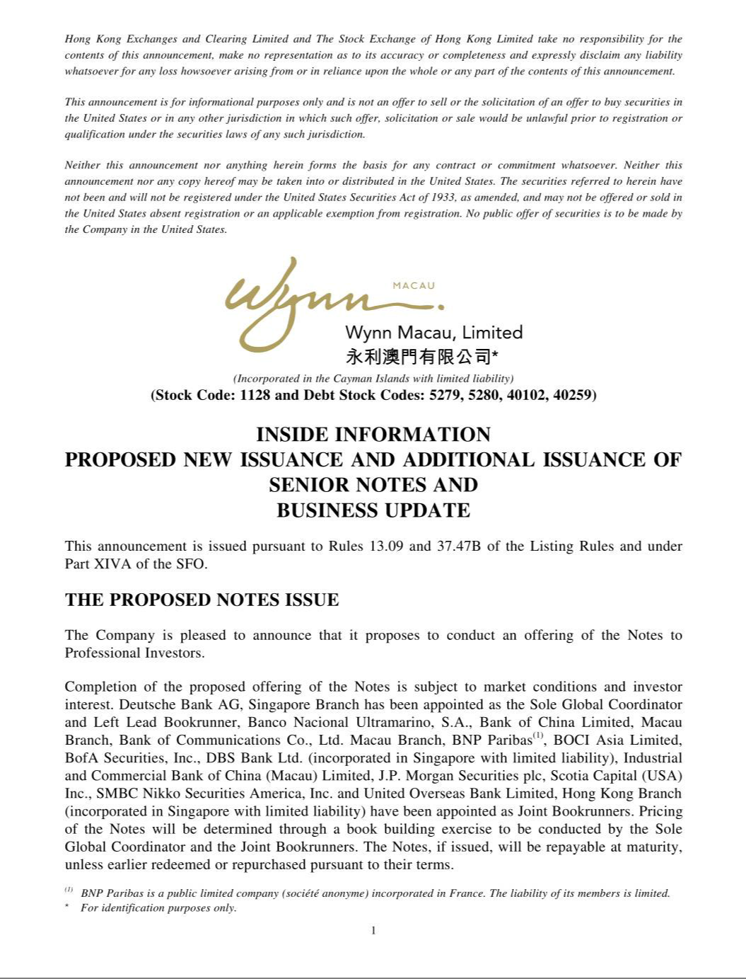

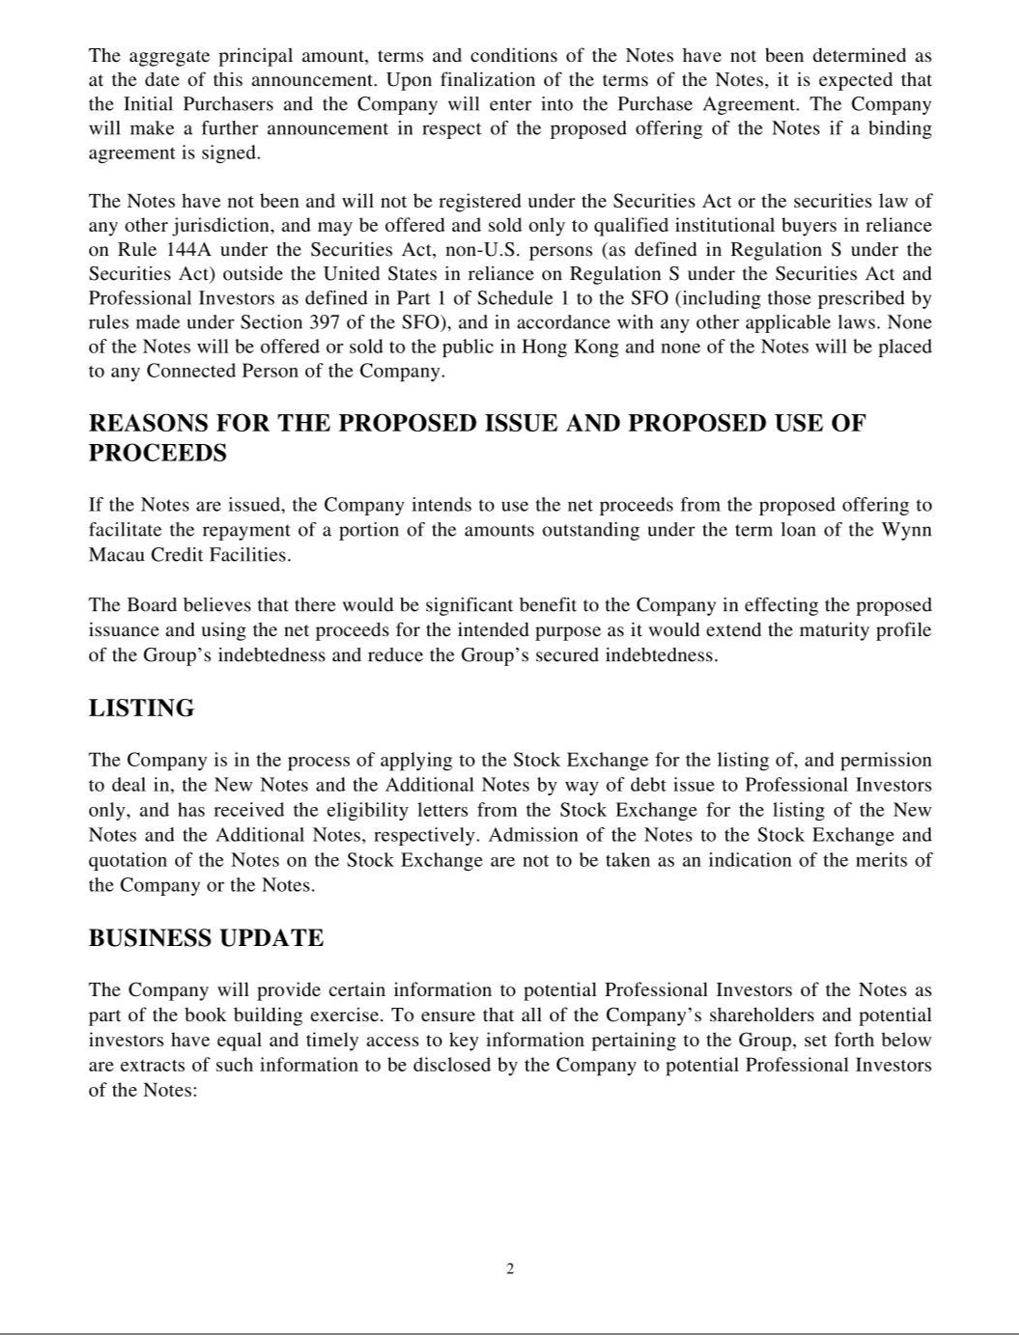

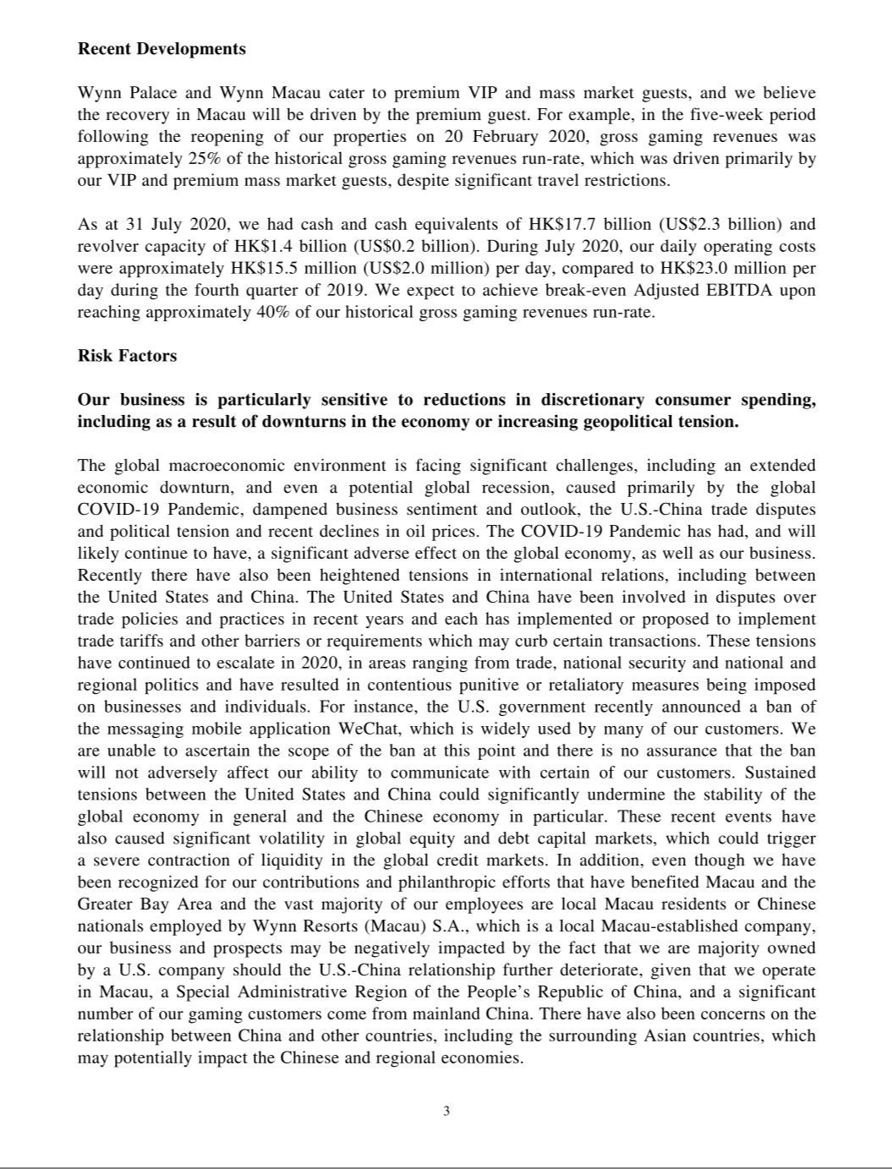

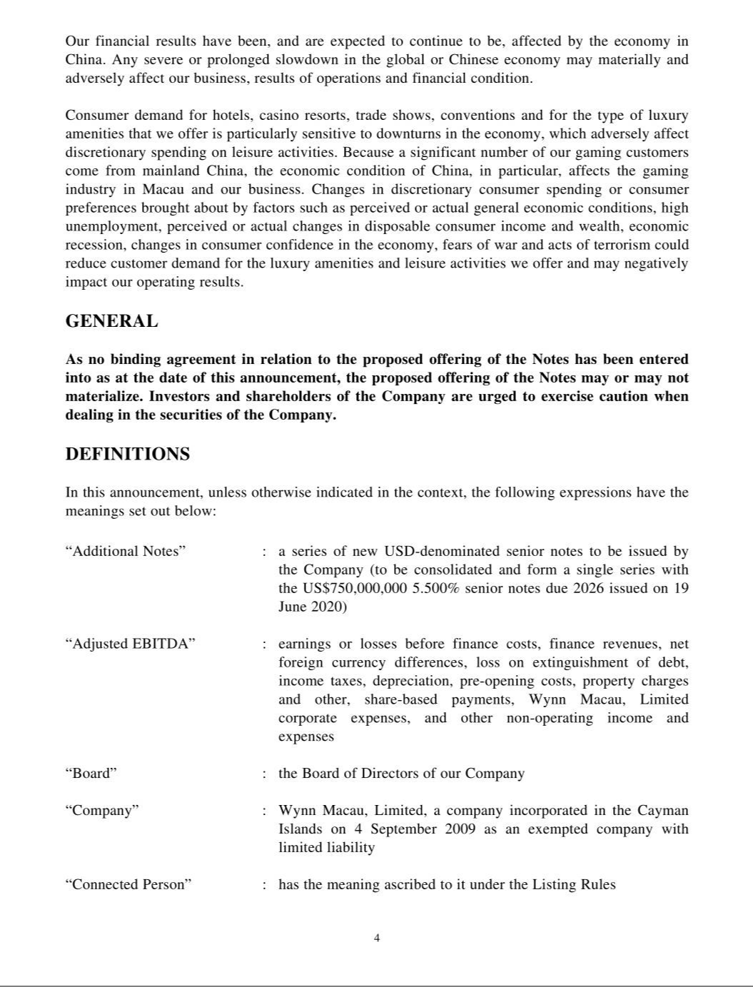

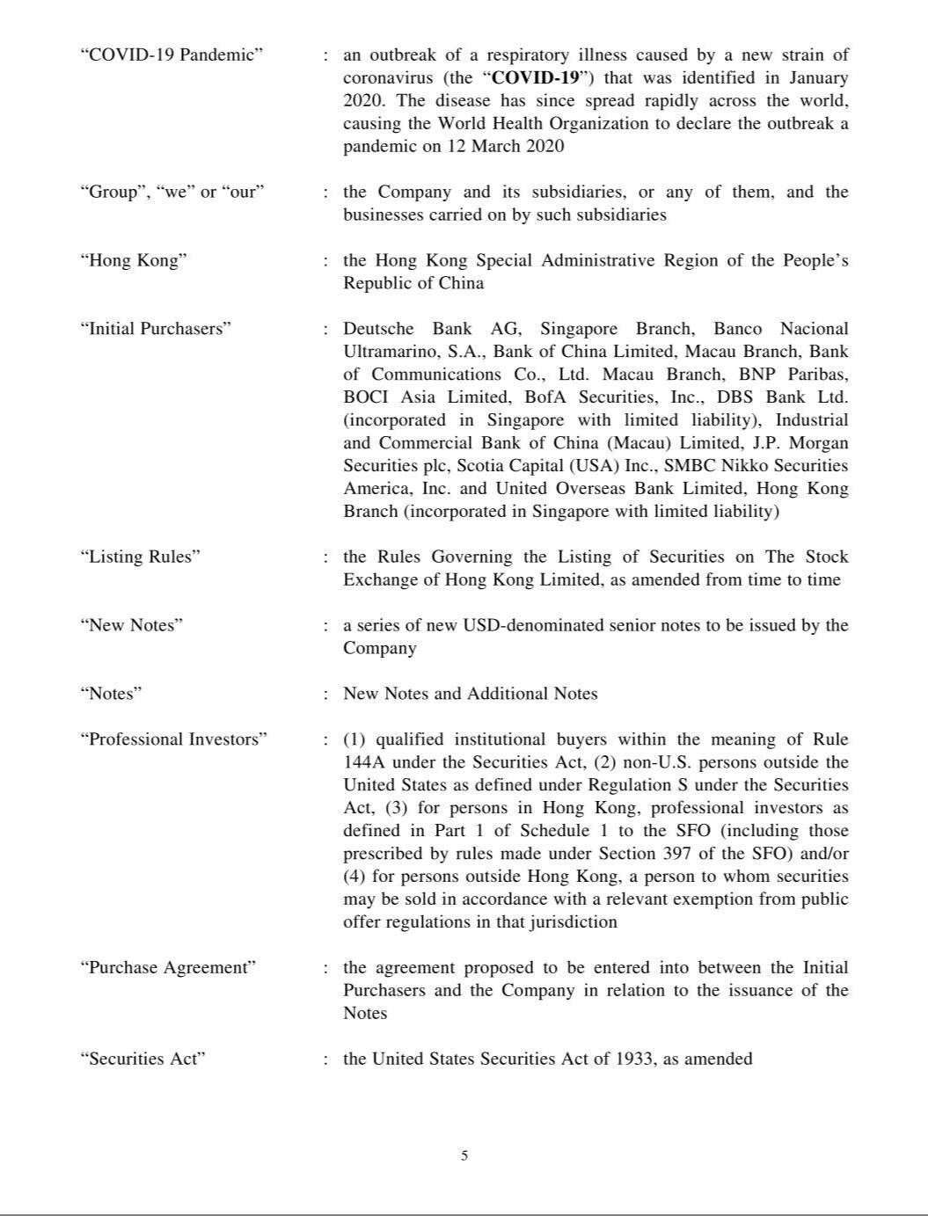

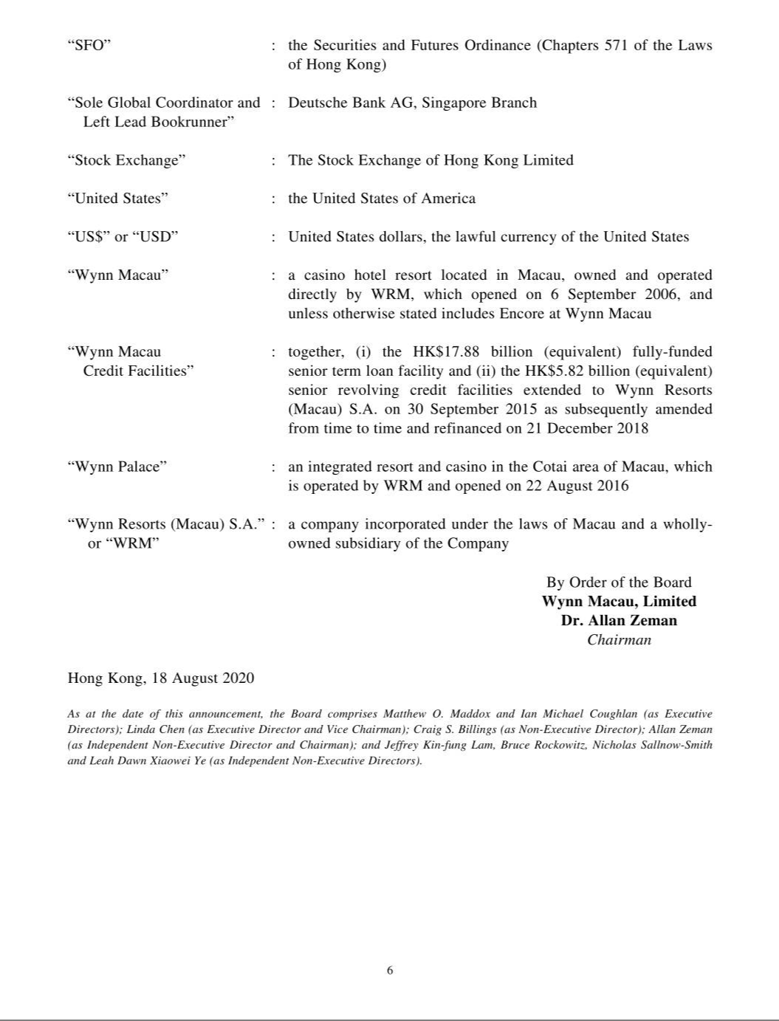

Exhibit 99.2

Recent Developments

In January 2020, an outbreak of COVID-19 was identified and has since spread around the world. As a result, our casino operations in Macau were closed for a 15-day period in February 2020 and resumed on a reduced basis on February 20, 2020. On March 20, 2020 our casino operations were fully restored; however, certain COVID-19 specific protective measures, such as various traveler quarantines, limiting the number of seats per table game, slot machine spacing, temperature checks, mask protection, requirement for negative COVID-19 test results for entering gaming area and health declarations remain in effect at the present time. Visitation to Macau has fallen significantly since the outbreak of COVID-19. Total visitation from mainland China to Macau decreased by 83.7% in the six months ended June 30, 2020, compared to the same period in 2019. According to the DICJ, gross gaming revenues in Macau declined by 77.4% in the six months ended June 30, 2020 and by 94.5% in July 2020, compared to the same periods in 2019.

The decrease in visitation is driven by the strong deterrent effect of the COVID-19 Pandemic on travel and social activities, the suspension in late January 2020 of the Chinese government’s visa and group tour schemes that allow mainland Chinese residents to travel to Macau, quarantine and testing measures in Macau and elsewhere, travel and entry requirements, restrictions and bans in Macau, Hong Kong, Taiwan and certain cities and regions in mainland China, and the suspension of ferry services to Macau from Hong Kong and mainland China and other modes of transportation within Macau.

At present, persons who are not residents of the Greater China area are barred from entry to Macau. Hong Kong and Taiwan residents as well as PRC citizens may be barred from entry to Macau dependent on their COVID-19 health test results and recent travel history. Quarantine requirements for those traveling between Hong Kong and Macau are in place and will remain effective until at least September 7, 2020, at which time they will be reviewed. Since June 30, 2020, Hong Kong has experienced a resurgence of confirmed COVID-19 cases. There is no assurance that existing quarantine requirements and conditions for travel between Hong Kong and Macau will not be extended or made more stringent.

While most of the abovementioned factors continue to weigh on visitation to Macau, certain of these travel related restrictions and requirements have eased since June 2020 as certain regions gradually recover from the COVID-19 Pandemic. Since mid-June 2020, certain groups of people such as students, teachers and certain non-Macau-resident workers who are PRC citizens could resume quarantine-free travel between Macau and Guangdong Province; provided that the traveler has had no recent travel history outside Guangdong Province, has tested negative for COVID-19 and has no known COVID-19 exposure or actual or suspected COVID-19 symptoms based on the traveler’s health declaration. Macau residents and certain other residents of Greater China with Chinese travel documents could resume quarantine-free travel from Macau to nine cities in Guangdong Province from mid-July, to the entire Guangdong Province from the end of July, and to most areas of mainland China from August 12, 2020; provided that the traveler has tested negative for COVID-19 within the past seven days and achieved green status under the Macau or Guangdong Province Health Code system, which requires a declaration from the traveler and a finding by governmental authorities that the traveler has no known COVID-19 exposure or actual or suspected COVID-19 symptoms.

Since August 12, 2020, the Chinese authorities have resumed the processing and issuance of non-tourist visas required for PRC citizens to travel to Macau for non-tourism purposes. In addition, since August 12, 2020, the Chinese authorities in Zhuhai have resumed the processing and issuance of tourist visas (including tourist visas for group tours and independent travelers under the PRC’s individual visit scheme (“IVS”)) to travel to Macau. Zhuhai is a PRC city adjacent to Macau. The IVS was operational in nearly 50 PRC cities prior to its general suspension by the PRC government due to COVID-19-related concerns. It has been announced that the IVS is currently expected to resume in Guangdong Province from August 26, 2020, and in the other participating PRC cities from September 23, 2020. We expect that our premium customers will lead the recovery of our business in Macau.

Notwithstanding the abovementioned developments, certain border control, travel-related requirements and conditions including possible quarantine and medical observation measures, stringent health declarations, COVID-19 testing and other procedures remain in place. Given the evolving situation associated with the COVID-19 Pandemic, we are currently unable to determine when travel-related restrictions and requirements will be further lifted. Measures that have been lifted and/or are expected to be lifted may be reintroduced if there are adverse developments in the COVID-19 situation in Macau and other regions with access to Macau.

As of July 31, 2020, Wynn Macau, Limited and its consolidated subsidiaries had cash and cash equivalents of HK$17.7 billion (US$2.3 billion) and HK$1.4 billion (US$0.2 billion) in available borrowing capacity under the Wynn Macau Revolver. During July 2020, our daily operating costs were approximately HK$15.5 million (US$2.0 million) per day, compared to HK

$23.0 million (US$3.0 million) per day during the fourth quarter of 2019. We expect to achieve break-even Adjusted EBITDA upon reaching approximately 40% of our historical gross gaming revenues run-rate.

Wynn Palace and Wynn Macau cater to premium VIP and mass market guests, and we believe the recovery in Macau will be driven by the premium guest. For example, in the five-week period following the reopening of our properties on February 20, 2020, gross gaming revenues was approximately 25% of the historical gross gaming revenues run-rate, which was driven primarily by our VIP and premium mass market guests, despite significant travel restrictions.

Adjusted EBITDA is earnings or losses attributable to the owners of Wynn Macau, Limited, as reported in accordance with IFRS in Wynn Macau, Limited’s filings with the Hong Kong Stock Exchange, before finance costs, finance revenues, net foreign currency differences, loss on extinguishment of debt, changes in fair value of interest rate swaps, income taxes, depreciation and amortization, pre-opening costs, property charges and other, share-based payments, Wynn Macau, Limited corporate expenses, and other non-operating income and expenses. Adjusted EBITDA is presented exclusively as a supplemental disclosure because management believes that it is widely used to measure the performance, and as a basis for valuation, of gaming companies. Management uses Adjusted EBITDA as a measure of our operating performance and to compare our operating performance with that of our competitors. We also present Adjusted EBITDA because it is used by some investors as a way to measure a company’s ability to incur and service debt, make capital expenditures and meet working capital requirements. Gaming companies have historically reported EBITDA as a supplement to financial measures in accordance with generally accepted accounting principles, in particular, U.S. GAAP or IFRS. In order to view the operations of their casinos on a more stand-alone basis, gaming companies have historically excluded from their EBITDA calculations pre-opening expenses and property charges, which do not relate to the management of specific casino resorts. However, Adjusted EBITDA should not be considered as an alternative to operating profit or loss as an indicator of our performance, as an alternative to cash flows from operating activities as a measure of liquidity, or as an alternative to any other measure determined in accordance with IFRS. Unlike net profit or loss, Adjusted EBITDA does not include depreciation or finance costs and therefore does not reflect current or future capital expenditures or the cost of capital. We compensate for these limitations by using Adjusted EBITDA as only one of several comparative tools, together with IFRS measurements, to assist in the evaluation of operating performance. Such IFRS measurements include operating profit or loss, net profit or loss, cash flows from operations and cash flow data. Also, our calculation of Adjusted EBITDA may be different from the calculation methods used by other companies and, therefore, comparability may be limited. Our Adjusted EBITDA presented above also differs from the Adjusted Property EBITDA presented by Wynn Resorts for its Macau Operations segment in its filings with the SEC in that Adjusted Property EBITDA excludes management and license fees and corporate overhead allocations, whereas Adjusted EBITDA does not, in addition to the basic differences that exist between profitability measures presented in accordance with U.S. GAAP and IFRS.

Risk Factors

Our business is particularly sensitive to reductions in discretionary consumer spending, including as a result of downturns in the economy or increasing geopolitical tension.

The global macroeconomic environment is facing significant challenges, including an extended economic downturn, and even a potential global recession, caused primarily by the global COVID-19 Pandemic, dampened business sentiment and outlook, the U.S.-China trade disputes and political tension and recent declines in oil prices. The COVID-19 Pandemic has had, and will likely continue to have, a significant adverse effect on the global economy, as well as our business. Recently there have also been heightened tensions in international relations, including between the United States and China. The United States and China have been involved in disputes over trade policies and practices in recent years and each has implemented or proposed to implement trade tariffs and other barriers or requirements which may curb certain transactions. These tensions have continued to escalate in 2020, in areas ranging from trade, national security and national and regional politics and have resulted in contentious punitive or retaliatory measures being imposed on businesses and individuals. For instance, the U.S. government recently announced a ban of the messaging mobile application WeChat, which is widely used by many of our customers. We are unable to ascertain the scope of the ban at this point and there is no assurance that the ban will not adversely affect our ability to communicate with certain of our customers. Sustained tensions between the United States and China could significantly undermine the stability of the global economy in general and the Chinese economy in particular. These recent events have also caused significant volatility in global equity and debt capital markets, which could trigger a severe contraction of liquidity in the global credit markets. In addition, even though we have been recognized for our contributions and philanthropic efforts that have benefited Macau and the Greater Bay Area and the vast majority of our employees are local Macau residents or Chinese nationals employed by Wynn Resorts (Macau) S.A., which is a local Macau-established company, our business and prospects may be negatively impacted by the fact that we are majority owned by a U.S. company should the U.S.-China relationship further deteriorate, given that we operate in Macau, a Special Administrative Region of the People’s Republic of China, and a significant number of our gaming customers come from mainland China. There have also been

concerns on the relationship between China and other countries, including the surrounding Asian countries, which may potentially impact the Chinese and regional economies.

Our financial results have been, and are expected to continue to be, affected by the economy in China. Any severe or prolonged slowdown in the global or Chinese economy may materially and adversely affect our business, results of operations and financial condition.

Consumer demand for hotels, casino resorts, trade shows, conventions and for the type of luxury amenities that we offer is particularly sensitive to downturns in the economy, which adversely affect discretionary spending on leisure activities. Because a significant number of our gaming customers come from mainland China, the economic condition of China, in particular, affects the gaming industry in Macau and our business. Changes in discretionary consumer spending or consumer preferences brought about by factors such as perceived or actual general economic conditions, high unemployment, perceived or actual changes in disposable consumer income and wealth, economic recession, changes in consumer confidence in the economy, fears of war and acts of terrorism could reduce customer demand for the luxury amenities and leisure activities we offer and may negatively impact our operating results.

